Prisoner Management System

# 

# Team Composition

Shahrose Khaliq 13L-4322  
Uzair Ahmed Bhatti 17L-4010  
Muhammad Saqib Kamran 17L-4154  
Muhammad Khuram Niaz 17L-4238  
Ali Haseeb 17L-6326

# Abstract

There are around 77 thousand prisoners in different prisons across the country. Handling such a large database is a very time taking and difficult task which is done through hand written record books. We propose a Prisoner Management System (PMS) which will provide a systematic management of records with an easy-to-use and secure interface. Our system will provide an adequate working environment for the prisons staff enabling them to administer the records and queries related to prisoners from the time they are brought into the prison. Our system will be implemented as a web-based interface using front-end, back-end and deployment technologies that are currently operational. The major objective of our system will be to manage details of prisoners, cells, crime details.

**Table of Contents**

Team Composition (on Title page) 1

Abstract 2

1. Introduction and Background 4

2. Problem Statement 4

3. Objective(s)/Target(s) 4-5

4. Completeness Criteria 5

5. Challenges 5

6. Knowledge Areas Required 5

7. Learning Outcomes 6

8. Nature of End Product 6

9. Initial Literature Survey 6

10. Miscellaneous 6

11. Project Plan 6-7

References 8

# Introduction and Background

“Automation is the creation and application of technologies to produce and deliver goods and services with minimal human intervention. The implementation of automation technologies, techniques and processes improve the efficiency, reliability, and/or speed of many tasks that were previously performed by humans”[3]. Today, automation is being used in many different fields in order to handle many human-oriented tasks in a much more productive manner. Thus, prison management is also one such task that can be achieved in an efficient manner through the process of automation. Therefore, **PMS** is an unravelment based on the process of automation that will help improve the conditions of prisons in Pakistan.

# Problem Statement

As of 2020, there are 99 established prisons in Pakistan with a total 77,275 prisoners (including pre-trial detainees/remand prisoners). Therefore, the need of the hour is to manage the large number of records in an efficient manner. However, most of the prisons in Pakistan follow a manual system to handle this large amount of data which can lead to many problems related to data loss, security and time management.

# Objective(s)/Target(s) The system shall allow the jail officer and the jailer the successful management of prisoners and their profiles.

* **Profiling of prisoners:**A Prisoner’s profile consists of:
  + Biodata (Name, Age, Date of Birth, Gender, Father Name)
  + Important Credentials (Address,CNIC)
  + Charges
  + Type of punishment   
     i. Date of execution (if applicable)
  + Duration of imprisonment
  + Courts Visited
  + Current Court
  + Current Prison
  + Prisons stayed in
  + Assets
  + Community Services
  + Cell type
  + Category
  + Beneficiary

# 1. The system shall allow Jail Officer to:

* Admit a prisoner in a suitable category by making a new prisoner profile.
* Update a prisoner’s profile.
* Initiate a prisoner transfer request to Jailer for approval.
* See a prisoner’s crime history, schedule for court hearings.
* Add a prisoner’s visitors on the basis of relation and day/time of visits.
* Update a prisoner’s cell type and category.
* Manage and supervise a prisoner’s tasks/community services.
* Add the beneficiary of a prisoner for his belongings.
* Manage a prisoner’s old hearing results from different courts.
* Manage a prisoner’s mode of transportation to and from prison to court.
* Manage a prisoner’s entry/exit date to and from the prison.

**2. The system shall allow Jailer to:**

* Approve/disapprove prisoner transfer request from current prison to another.

# Completeness Criteria The project shall be considered complete when it enables a jail officer and jailer to carry out their respective tasks mentioned in the section above. The minimum completion criteria shall be managing (adding, editing) prisoners profiles and their respective data.

# Challenges

* Getting familiar and comfortable with new technologies/platforms to be used for this project’s implementation.
* Integration Issues
* Issues while modelling the problem.

# Knowledge Areas Required

Knowledge of core concepts from areas required to implement this project include the following:

* Database Systems
* Object Oriented Analysis & Design
* Web Programming
* Human Computer Interaction
* Software Engineering
* Full Stack Development

# Learning Outcomes

* Getting familiar and comfortable with the new platform/technology being used
* Managing integration
* Improved team learning and management
* Project management skills

# Nature of End Product

The system should keep record of prisoners from the time they are brought into prison till they are released. The system should also keep profiling the prisoners. Along with this, the system should be able to perform searching in an easy and human-friendly manner. It should minimise human intervention and reduce paper work. Furthermore, the system should be accessible from all prisons. To conclude, the system should perform efficiently and our final product will be a web application which will allow successful prisoner management and profiling.

# Initial Literature Survey

A prison management system was proposed for Ghana’s prison by MAK Systems. The purpose of proposing this system was that proper facilities were not in place to ensure storage and retrieval of information on prisoners quickly because of traditional big files with manual entries. This project was to be developed on testing purposes to see either it works efficiently and according to the needs or not. It is different from our project in a sense that our project is going to make use of proper graphical user interface rather than just very basic java interfaces. The web application would be convenient to use. Our system will eliminate data redundancy and ensure data integrity.

# Miscellaneous

The final system would be deployed on a localhost and testing would be done using two or more laptops using the same network(LAN). The data would be stored in a local database.

# Project Plan

## Activity on Node Diagram

The figure below represents the Activity on Node Diagram of PRisoner Management System. It can be clearly seen that it will take at least 39 days to complete this project.

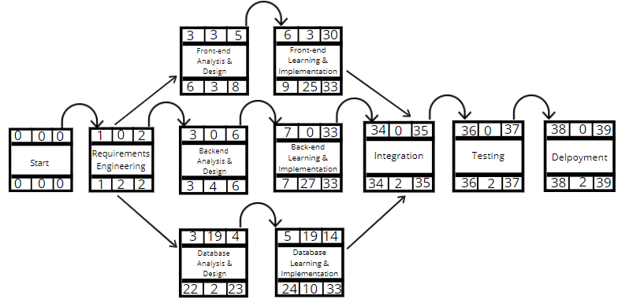

Figure 1: Activity on Node Diagram

## Gantt Chart

The following diagram shows the gantt chart for the Prisoner Management System in terms of days.

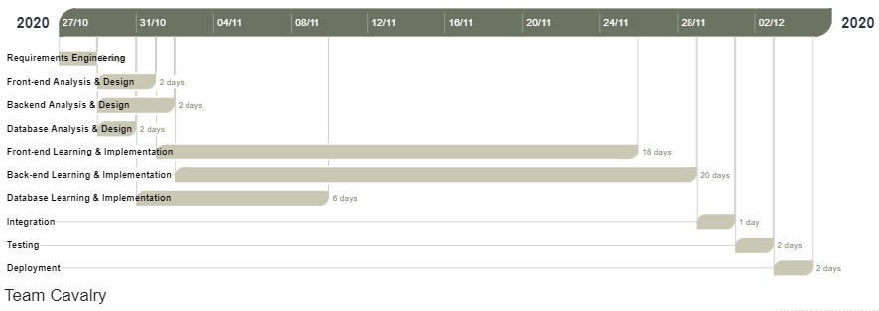

Figure 2: Gantt Chart Prisoner Management System

# References

[1] Joel K., Nana G. *Prison Management System Project Proposal*. November 2, 2010 <https://idoc.pub/documents/prison-management-system-project-proposal-pon2pv3vw040>

[2] Million G., Kibrom H. *Prison management system, Exercises for Object Oriented Analysis and Design*. December 14, 2019  
<https://www.scribd.com/doc/40824549/Prison-Management-System-Project-Proposal>

[3] Masood K. *The Prison System in Pakistan*. July 3, 2010 [http://www.pjcriminology.com/wp-content/uploads/2019/01/3-24.pdf](https://meet.google.com/linkredirect?authuser=0&dest=http%3A%2F%2Fwww.pjcriminology.com%2Fwp-content%2Fuploads%2F2019%2F01%2F3-24.pdf)

[4] Human Rights Commission of Pakistan. *World Prison Brief.* December 13, 2013 <https://www.prisonstudies.org/country/pakistan>

[5] Techopedia. *Automation.* August 7, 2020 <https://www.techopedia.com/definition/32099/automation#:~:text=Automation%20is%20the%20creation%20and,were%20previously%20performed%20by%20humans>